**Service Account Creation for HPECP Environment**

1. Login to respective ECP Environment for which the user requested for the service account creation
2. Navigate to the Users section as highlighted in below SS and click on **Add User** button:

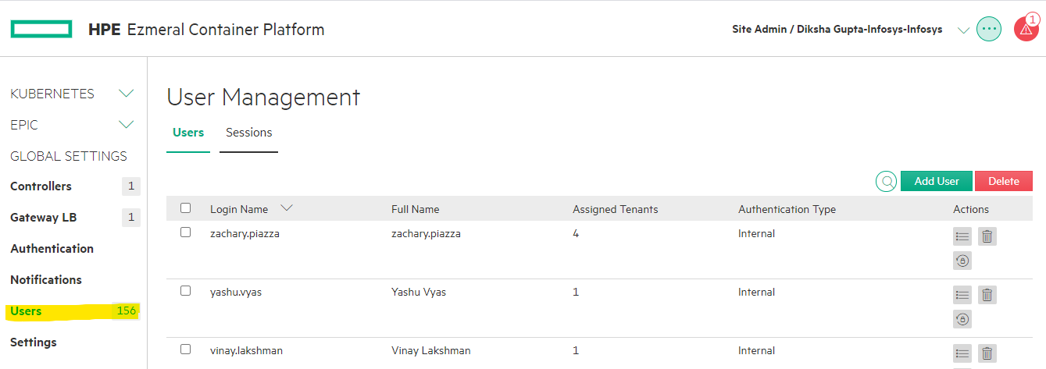

1. If the user requested for a service account with name **service-ecp,** fill in the details as below:

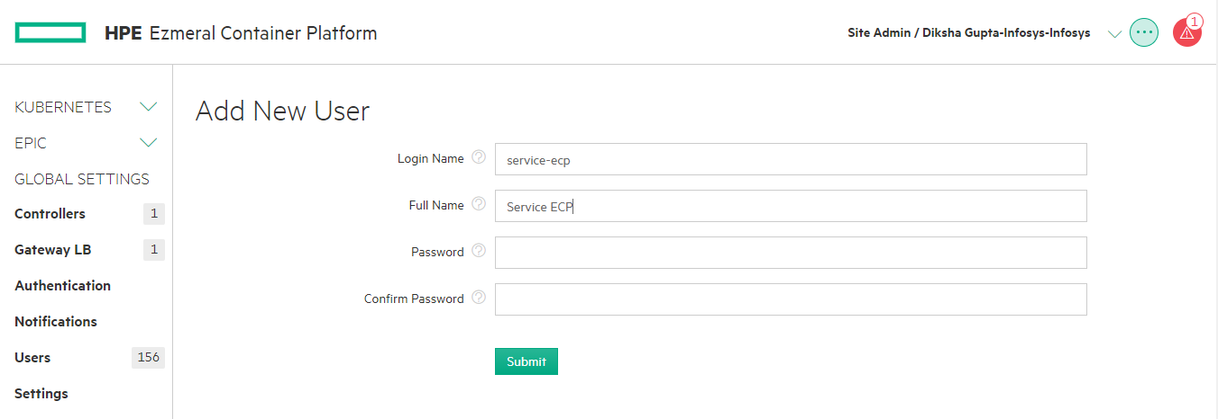

1. For setting up the password, click on the below link to create a strong password for the service account: <https://passwordsgenerator.net/>
2. Make sure the criterias are met as shown in the SS. Generate the password by clicking on the **Generate Password** button. Copy and save the password somewhere to forward it to the User.

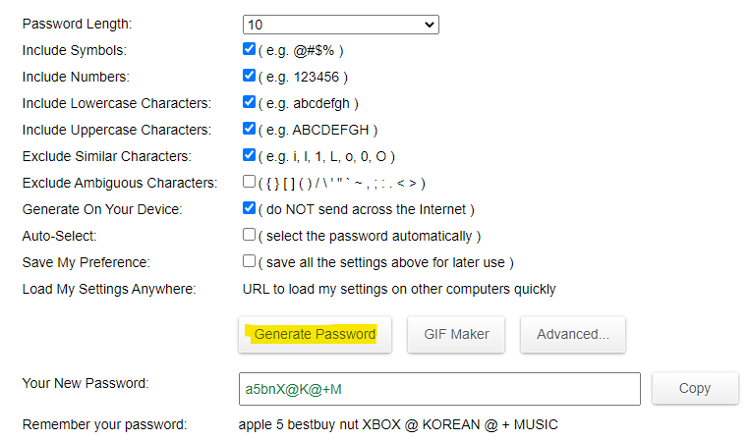

1. Provide the password copied in the previous step and click on submit button.

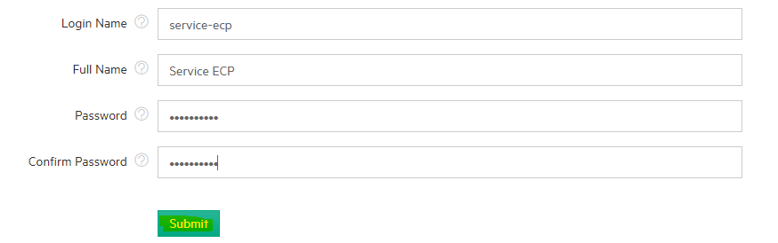

1. Once the service account is created, go to tenants and look for the tenant name for which the service account creation was requested and click on it.

**Note:** Alternately, once the service account is created, you can go to Users section as shown in #2 and assign tenant to the user. It is recommended as it will work even during site lockdown.

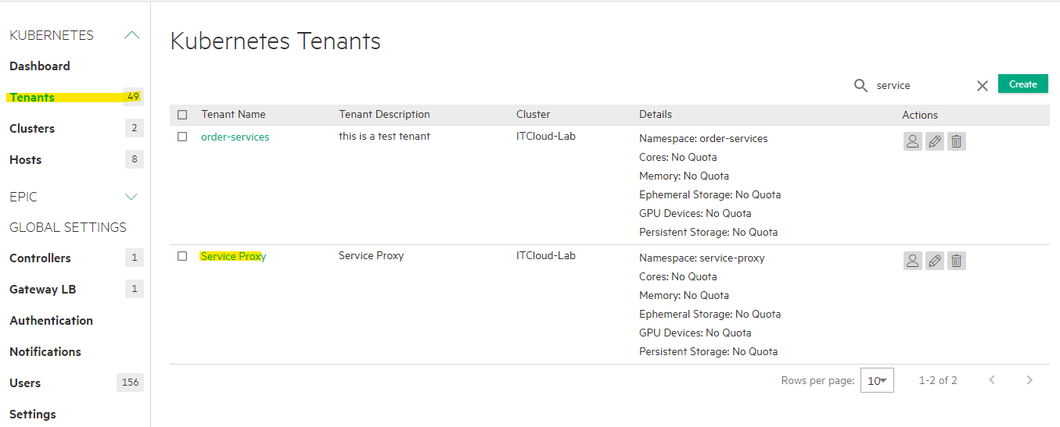

1. Once inside the Tenant, go to **Users** tab and click on **Assign** button

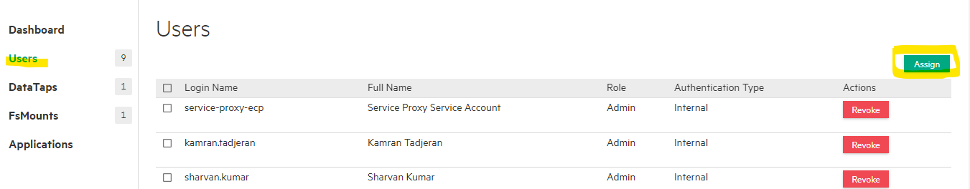

1. Look for the service account name in the list and select it.
2. Once selected, the service account shows on right side of the screen. Select the **Admin** role and click on **Save**.

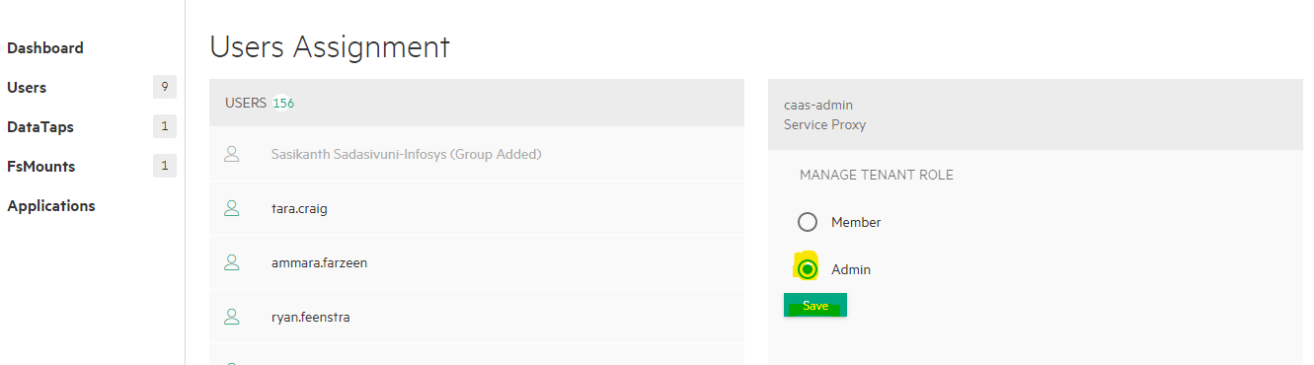

1. Send out an email to the user who requested for the service account following the below example template. (keep team members in CC – get it from the mail the user sent out for the service account creation).

**Subject of the mail**: CoLo2-ITG Ezmeral Container Platform Service Account Credentials

**Content**:

Hi Team,

We have added below service accounts into CoLo2-ITG Ezmeral Container Platform (ECP) environment.

Please find the URL and credentials of HPE ECP CoLo2-ITG environment and make sure to change your password after your first login.

HPE ECP CoLo2-ITG URL: <provide the respective environments URL>

**Namespace** - service-proxy

**Service Account Name -** service-ecp

**Initial Password** - U33vMr]8D:

HPE ECP environment Wiki reference: <https://github.hpe.com/CaaSonHPE/Wiki/wiki/HPE-IT-Ezmeral-Container-Platform>

Please reach out to the platform team through [Flowdock-channel](https://www.flowdock.com/app/hpe/hpeit-ecp-hub) by tagging **“@@platform_team**” if you face any access issues.

Thanks,

Name